OUR TRAINING COURSES
A. SUPERVISORY SKILLS TRAINING
Module 1: Foundational Skills for Supervisory Excellence (3 days)
. Becoming a supervisor
. Supervisor as a leader: The essence of leadership
. Optimizing employee performance
. Communication essentials
Module 2: Managing Employee Issues:
. Induction and Employee Engagement
. Addressing performance issues: Decoding performance management
. Equal employment opportunity, harassment, discrimination and bullying prevention
. Employee safety, reasonable accommodation and medical Issues
Module 3: How to Build and Maintain a High-Performance Team (3 days)
. Team working and Development
. Employee Development: Coaching and Mentoring
. Conflict Management
Module 4: Making It Happen: Enhancement and Application of Skills
(2 days)
. The Power of Role - modelling
. Loyalty and Accountability
. Time and space management
. Meeting facilitation
. Leading organizational change
. Action planning: Getting the most from the series

- Mid-Level Management Development
Managing for Performance (5 days)
Module 1: Strategic Thinking
Module 2: Solving Managerial Problems
Module 3: Critical Thinking Tools
Module 4: Negotiation Skills

B. Personal Development: Enabling a culture of Teamwork

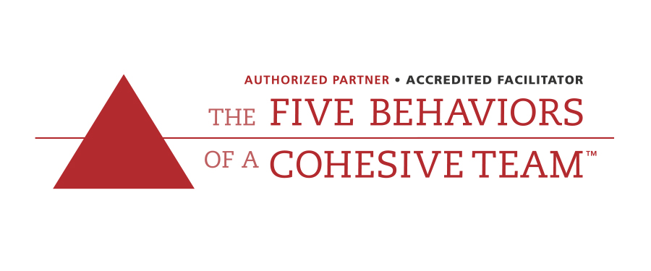

The Five Behaviours of a Coherent Team program is a unique learning experience that helps individuals understand how to effectively work together by applying the five behaviours of teamwork to the workplace. We bring this powerful team model to life for our clients.
Grow your business with:

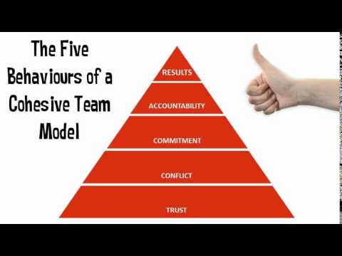

Below is a brief summary of the five behaviors.
• Trust One Another - When team members are genuinely transparent and honest with one another, it forms a safe environment that creates and builds vulnerability-based trust.
• Engage in Conflict Around Ideas - With trust, team members are able to engage in unfiltered, constructive debate of ideas.
• Commit to Decisions - When team members are able to offer opinions and debate ideas, they feel heard and respected, and will be more likely to commit to decisions.
• Hold One Another Accountable - Once everyone is committed to a clear plan of action, they will be more willing to hold one another accountable.
• Focus on Achieving Collective Results - The ultimate goal is the achievement of results, unlocked through implementing the model’s principles of Trust, Conflict, Commitment, and Accountability.
A Productive, Highly Performing Team:
• Feels safe to ask for help and express their opinions
• Avoids wasting time and energy on politics, confusion, and destructive conflict
• Is committed to the end goal
• Holds one another accountable
• Has more fun—and delivers results!

C. DISC PERSONALITY PROFILING

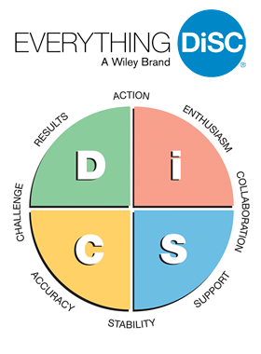

What Is Everything DISC?
Everything DiSC® is a personal development learning experience that measures an individual’s priorities and tendencies based on the DiSC® model.
Participants receive personalized insights that:
• Deepen their understanding of self
• Inspire appreciation of other work styles
• Enable more enjoyable, effective interactions.
The result is a more engaged and collaborative workforce that fosters meaningful culture improvement.
We believe an organisation’s true potential lies within its people. Our purpose is to ignite cultural transformation by empowering all people to engage, connect and thrive in the workplace.
We welcome change and embrace the uncertain. We leverage data and stories and develop social and emotional intelligence. We are champions of diversity and acceptance and we believe in people above all else.
DISC Application Suite:
1.Workplace – Engage every individual in building more effective relationships at work.
2. Management – Teach managers to successfully engage, motivate and develop their people.
3. Work of Leaders – create impactful leaders through the process of vision, alignment and execution.
4. Productive Conflict – Harness the power of conflict by transforming destructive behaviour into productive responses
5. Sales – provide sales-people with the skills to adapt to customers preferences and expectations.
6. 360 For Leaders – Elevate leadership effectiveness with our dynamic 360 degree feedback tool.
The result is a more engaged and collaborative workforce that fosters meaningful culture improvement.
Everything DISC opens the doorway to effective communication, allowing you to modify your language and behaviour to manage people in any given environment. People are different but they are predictably different. People respond to people they like and understand.
Grow your business with Everything DISC – a Wiley brand. It relies on a model of human behaviour that has been rigorously tested and proven over the last 40 years. The technology used ensures that everyone gets a report that reflects who they really are. Our learners carry the four personality styles out of the classroom and can immediately infuse the ideas into their work culture

We are:
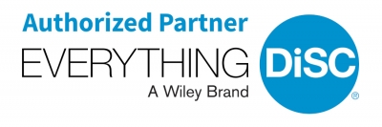

D. Leadership Skills Training for Directors/Deputy Directors /Senior Managers (3-5 days)

This is a customised leadership programme, based on the CIPD/Institute of Leadership and Management (ILM) resources. As members of the Institute, we have access to a vast range of resources and tools to assist and your people develop confidence, overcome challenges and get ahead in your chosen careers. Our relationship keeps us informed of current and robust research and best practices, expertly curated training materials, webinars, podcasts, worksheets.
Our leadership development programme is based on the 10 Top Leadership Competencies identified by Havard Business Review after assessing 74 leadership qualities, and is grouped into the following skill themes:
- Strong Ethics and Safety
- Self-Organising
- Flexibility and efficient learning
- Nurtures growth
- Connection and Belonging

Modules can also be developed based on the following seven core leadership competencies:

- Setting a clear direction by having a vision of the future, a strategy for bringing that vision into reality and a set of values of what is important in terms of how you run your business.
- Managing to ‘fire up’ your team so that everybody is committed to the business in terms of making it successful.
- Setting an example in terms of how you personally operate on a daily basis in respect of time management, focus on priorities, cope with pressures and deal effectively with customers.
- Creating a plan for each person in the business in terms of developing the knowledge, skills, attitudes and competencies they need to possess in order to work effectively both now and in the future.
- Communicating effectively with both staff and customers. For example, how often do you brief everybody in your team about what is happening
- Actively pursuing a continuous performance improvement programme to identify better ways of doing things, and then following through with the changes.
- Coping with a crisis. For example, do you try to solve everything yourself, or do you try to delegate the problems where possible?

Customization Options
Any of the modules or courses above may be customized for clients depending on the needs of the organization. This may include:
. Adding courses
. Deleting courses
. Changing the order or number of courses or modules
. Tailored assessments, case studies, data sets drawn from your workplace etc.

Sessions and other means are adopted to maximize positive impact for your organization. Give your team the tools and resources they need and witness their productivity soar!

E. Intercultural Competence Enhancement Training.

A 2011 graduate of the renowned Intercultural Communication Institute (ICI) Portland, USA, Penkz Consultants are authorised to use the Bennetts’ Developmental Model of Intercultural Competence. We are members of the Society for Intercultural Education Training and Research (SIETAR, UK), promoting the development of intercultural competence and inclusive management and reduction of conflicts among people, thereby enhancing mutual respect in the workplace in particular and peaceful co-existence in society in general.

F. Artificial Intelligence (AI) For Better Ways of Working

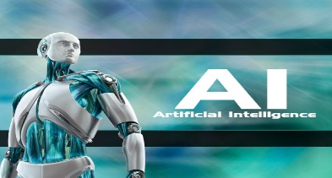

As technology relentlessly moves forward, the talent acquisition function must transform to better support the job-seeker and emerging business needs. Little wonder, organisations, big or small, are battling with what is next in working and learning, in terms of skills gap and how to address the gap.

For individuals, the gap between the skills you currently have and the skills you need to do work now and in the future. For organisations, the difference between skills that we want or (will) need and the skills the workforce offers – not just technical or software but essential interpersonal (soft) skills.

We are investing hugely in understanding the fundamentals of artificial intelligence and determining how we can apply AI to enhance candidate and employee experience. We hope to build this into our course offerings in the months ahead.

G.EMOTIONAL INTELLIGENCE ENHANCEMENT TRAINING

John Mayer and Peter Salovey (1990) defined emotional intelligence as: “the ability to monitor one’s and other’s feelings and emotions, to discriminate among them, and to use this information to guide one’s thinking and action”. In 1996, David Caruso joined John and Peter to create an ability-based test, like an IQ test, that measures a person’s ability to perceive, use, understand and manage emotions. After several years, they created the Mayer, Salovey, Caruso Emotional Intelligence Test (MSCEIT) which measures a person’s emotional intelligence and helps them leverage their strengths and become aware of areas they may want to develop.

We are licensed to facilitate understanding and application of the ability-model of emotional intelligence.

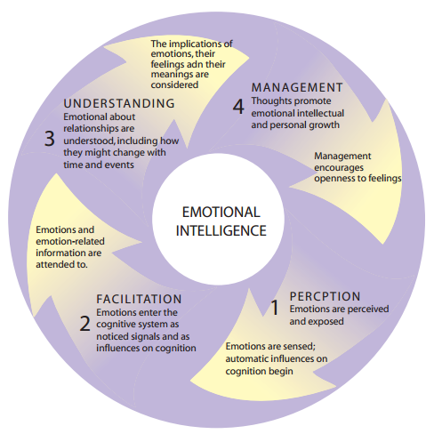

H. Corporate Governance and Anti-Corruption Training

